Topic: Introduction to Computers

When I am done this lesson, I will know:
- What a computer system is
- Why computers are important in all parts of life

Pre and Post Self-Assessment
 | Pre | Pre | Post | Post
 | Yes, I know this | No, I want to learn this | Yes, I know this | I still need more practice to learn this
I know the difference between a desktop and laptop computer.
I know the ways computers are used at work
I know how computers are used for learning
I know how computers can help me with everyday tasks.

New Words and Terms

Hardware
Software
Peripheral device
Desktop
Laptop

What is a computer system?
A computer system has three main parts:
- hardware
- software
- People
Hardware is the equipment. It is the physical parts. It includes the parts you can see and some parts that you cannot see. Hardware includes the processor, memory, storage, communication ports and peripheral devices. Peripheral devices are connected to the computer. Some examples are the display, the keyboard, mouse, speakers, and printer. The processor is what makes the computer work. It is like the “brains” of the computer.
Software is a set of instructions or a computer program that tells the hardware what to do. The operating system of a computer is one type of software. There are also thousands of other types of software programs that you can use on a computer. Some of the most common software programs you might use are Microsoft Word or Adobe Acrobat. Software is written by a computer programmer.
People use the software to tell the computer what they want it to do for them.
There are different types of computers. They can have different computing power, capacity, size, mobility and other factors. Some different types of computers are:
- desktop computers,
- laptop computers,
- minicomputers,
- handheld computers and devices,
- mainframes or supercomputers.

 | Watch this to learn more about what a computer is.  Source: GCFGlobal.org | https://www.youtube.com/watch?v=7cXEOWAStq4

You are probably using a desktop computer or a laptop computer.
Desktop Computer | Laptop Computer
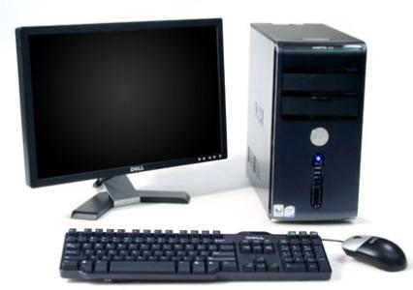 | 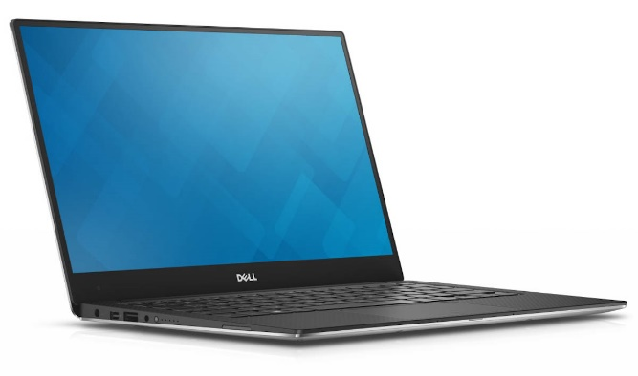
- A desktop computer has a few different parts.  - A desktop computer needs to have a place to sit. It usually sits on a desk which is why it is called a desktop.  - A desktop computer needs to be plugged in order to work. | - All the parts are combined in a laptop computer.  - A laptop computer can be moved around. You can even have it on your lap which is why it is called a laptop computer.  - A desktop computer has a built-in battery. You need to plug a laptop computer into a power source to charge the battery. If the battery is charged you can use it unplugged.  - Sometimes laptop computers are called notebook computers

Check Your Knowledge
What are the three main parts of a computer system?
1.
2.
3.

What are two differences between a desktop computer and a laptop computer?
________________________________________________________________
________________________________________________________________

Computers are used in all parts of our lives today. We use computers in the workplace, in school settings and in our everyday lives.

Examples of computers at work

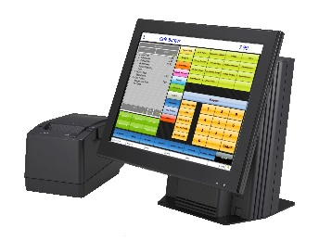 | Retail associates look up customer names, addresses and product information on a computer.
 | Factory workers need to use computer scanners to look up product information.
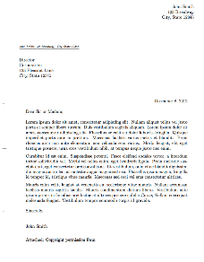 | Office workers use word processing software to write letters.
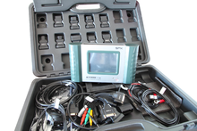 | Mechanics use computers to match fault codes with engine problems.

Discussion Question
Can you think of any other examples?

Examples of computers at school

 | Students apply to schools online.
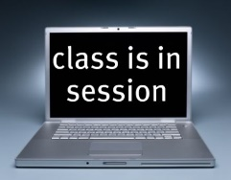 | Some courses are done on a computer.
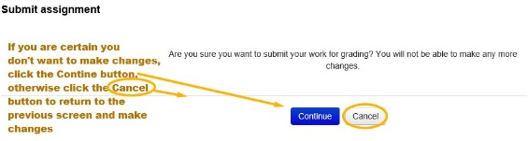 | Assignments are usually done on a computer.
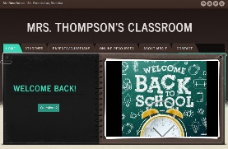 | Many teachers have online class websites.

Can you think of any other examples?

Examples of computers in our everyday lives

 | Storing photos online.
 | Messaging friends and family using social media.
 | Online banking.
 | Shopping online.

Discussion Question

Can you think of any other examples?

Check Your Knowledge

Write down three different places computers are used:
1.
2.
3.
Share your answers with the group.

Optional: I want to learn more

Complete the GCFGlobal: Computer Basics- What is a Computer Course: https://edu.gcfglobal.org/en/computerbasics/what-is-a-computer/1/

Ontario Adult Literacy Curriculum Framework Connection
Competency | Task Groups(s)
Find and Use Information | - Read Continuous Text  - Interpret Documents  - Extract Information from films, broadcasts and presentations
Communicate Ideas and Information | - Interact with Others  - Complete and Create Documents

